Wednesday, 23 September 2026, postcard

Cannes to Tallahassee

We had to have our luggage out at 6:15 am and were ushered, with one other couple, into our limo at 6:45 am, for a 9:30 am flight out of Nice.

All went smoothly except for one lollopalooza of a goof on my part. I did just what we had been warned repeatedly not to do—left for the airport without retrieving my passport from the safe in my hotel room. I didn't realize it until we got to the airport and prepared to check in. David went ahead through check-in and security—no point in our both missing the flight.

Meanwhile, I desperately tried to reach Concetta—I finally had to call the cruise director on the ship and ask him to have her call me. After one false start, where she and the hotel manager went to David's room rather than mine, they retrieved the passport. Concetta jumped on the next transport to the airport (they were dispatching one every 20 min or so) and delivered it to me, waiting on the sidewalk at passenger dropoff outside the domestic terminal, at 8:55 am. I dashed for check-in, had to unload all my electronics (no TSA precheck in Europe), got through security (full pat-down and wanding because the little metal buckles on my waistband set off the metal detector), rushed to the gate, and starting pushing forward to see whether my zone had already loaded, at which point I found myself standing next to David, just as they called our zone. Whew!

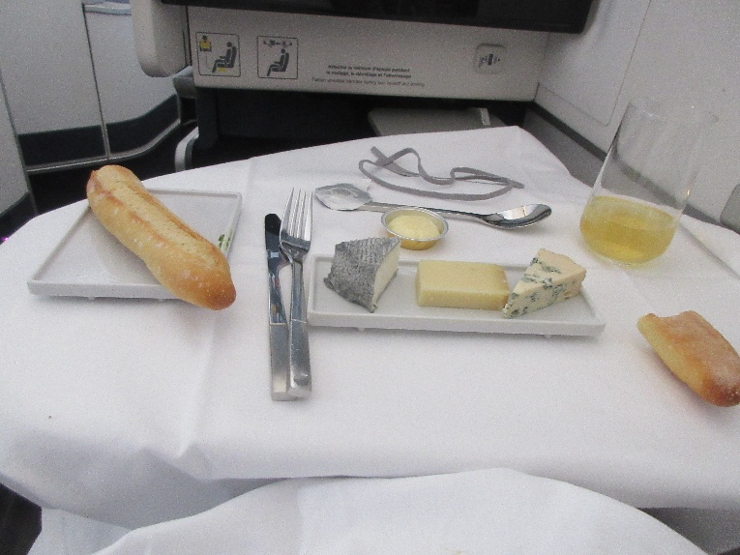
Lovely food on the flight, including this great cheese course.

I considered napping, but decided what the heck and watched four movies instead: The Mandalorian and Grogu, Guardians of the Galaxy 3, Jersey Boys, and Little Shop of Horrors.

The promised limo was waiting for us in Tallahassee, and we were in bed before midnight.

